

**Name: Syed Muhammad Fahad Fiaz**

**Roll No: BSSEM-S24-036**

**Section: SE 3A**

**Subject: Data Structure and Algorithms**

**Submitted To: Sir Rasikh Ali**

**Submission Date:**

**Assignment 9**

**DSA LAB TASK’S**

**LAB 11:** Queue with Linkedlist and Array

Tasks:

1. With Array; Enqueue, Dequeue, Display

2. With Linkedlist; Enqueue, Dequeue, Display

**Explanation:**

**Queue using Array (Theory)**

* **Enqueue** (Insert):  
  Add new element at the rear index.  
  Increase rear by 1.
* **Dequeue** (Remove):  
  Remove element from the front index.  
  Increase front by 1.
* **Display**:  
  Print elements from front to rear - 1.

**Important:**  
Queue with array has **fixed size**.  
When array fills up, you **can't add** without shifting or circular techniques.

**Queue using Linked List (Theory)**

* **Enqueue** (Insert):  
  Create a new node.  
  Add it at the **end** (rear).  
  Update rear pointer to the new node.
* **Dequeue** (Remove):  
  Remove the node from the **front**.  
  Move front pointer to the next node.
* **Display**:  
  Print all nodes from front to rear.

**Important:**  
Queue with linked list is **dynamic**.  
You can add **unlimited elements** without worrying about size

**OUTPUT USING ARRAY**

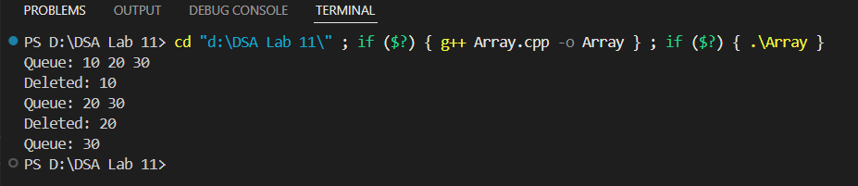

**OUTPUT USING Linked List**

